

Connectivity Scenario of SMS Reload, Toll, Parking Application and Other MOTO Merchants

Table of Contents

1. Change History 2
2. Document Approval 3
3. Audience 3
4. Transaction part 3
4.1. “API” model scheme 3
4.2. Buying steps 4
4.3. “API” transaction integration model in short 4
5. Merchant administration 5
6. Merchant integration with NestPay transaction and back-office system 5
6.1. Downloading the manuals form Merchant Center (test) 5
6.2. Development of Merchant test system 6
6.3. Creating API role user 6
6.4. Test Merchant system 6
6.5. Switch to production 6
7. Notes: 7
8. Abbreviations 7

Change History

The following table shows the history of document changes.

Document  version | Description | Pages | Issue Date | Author
1.0 | Initial Version |  | 3th February 2016 | New Channels team

Document Approval

The following table shows a list of stakeholders who have approved the document.

Stakeholder | Role | Approval Date | Approval method
Kristijan Pleše | Team Leader (ISPC) |  | e-mail

Audience

For BIB Merchants who are selling mobile vouchers like SMS reload, toll, parking or other products as MOTO merchant. They don’t have/use payment page for collecting card data but SMS messages, e-mails, mobile phone applications or fix phones.

Transaction part

For BIB MOTO merchants “API” model will be used for accepting authorization messages.

The main characteristics of this way of integration are:
- there is no payment page and all transaction data is sent to the Merchant by different means: e-mail, mobile phone application, phone call, …
- card holder data are collected on Merchant side
- Merchant back-office system could be integrated with NestPay back office system

“API” model scheme

Ecommerce buying steps for “API” model of integration are described on below scheme:
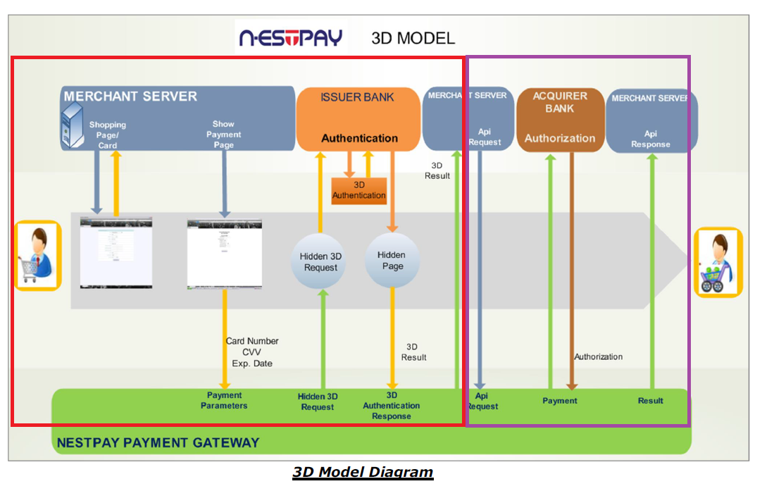
Note: there is no standard payment page
“3D Model Diagram” represents buying steps, starting from the most left yellow arrow, in two main models/parts. The timeline starts on left and ends on right. For MOTO merchants the part in purple rectangle is used “API” model for authorization messages. The Merchant system is on upper part (blue boxes), Customer is in the vertical middle (gray box) and NestPay system on lower part (green box).

Buying steps

API model part on Diagram:
- Customer wants to pay some product like mobile voucher, toll or parking ticket over the SMS messages, e-mails, mobile phone applications or fix phones
- Merchant system sends “API Request” to NestPay with all necessary parameters
- NestPay sends “Authorization” request to BIB
- BIB sends “Authorization” response to NestPay
- NestPay sends “API Response” to Merchant system

“API” transaction integration model in short

In “API” model MOTO merchant should sent API request to NestPay API service TEST link
https://testsecurepay.intesasanpaolocard.com/fim/api.

Note: for PRODUCTION link is https://bib.eway2pay.com/fim/api.

How to generate API authorization requests is described in “ISPC_Nestpay_Merchant Integration API Manual.pdf” manual:
- “API” model is provided for the merchants so that they can send authorization messages:
  - Primary transactions (preauthorization, auto-postauthorization)
  - Secondary transactions (postauthorization, void, refund)
  - Order status query
  - Order history query
Note: Names for types of authorization and following transaction messages in comparison to other used names:
- preauthorization = preauthorization/authorization with completion
- auto-postauthorization/sale = authorization/ authorization without completion
- postauthorization = completion
- void = reversal/cancellation transaction
- refund = refund
- order status query = authorization check status/completion check status

Merchant administration
Merchant administration back-office system is NestPay Merchant Center.

There are two instances of Merchant Center:
- TEST https://testsecurepay.intesasanpaolocard.com/bib/report/user.login
- PRODUCTION https://bib.eway2pay.com/bib/report/user.login

It is used for:
- administration:
  - orders
  - transactions
  - users
  - merchant parameters for connection to NestPay transaction system
- searching:
  - downloading needed documents for integration with NestPay transaction system
  - bank information
  - help
and many other things related to NestPay transaction system. Details can be found in “Inhouse_NestPay_MerchantCenterUserManual.pdf” manual.

Merchant integration with NestPay transaction and back-office system

In following paragraphs will be described the main steps of merchant integration, with links and documents for integration.

Downloading the manuals form Merchant Center (test)

Login to test Merchant Center with Merchant Id, Username and Password for Merchant Administrator role provided by BIB on TEST link https://testsecurepay.intesasanpaolocard.com/bib/report/user.login and download the manuals.

Note: for PRODUCTION link is https://bib.eway2pay.com/bib/report/user.login

There are three main manuals:
- “ISPC_Nestpay_Merchant Integration API Manual.pdf” - transaction manual for authorization API requests and responses with explanations of mandatory/optional parameters and examples
- “Inhouse_NestPay_MerchantCenterUserManual.pdf” - merchant administration manual for Merchant Center back-office system

Development of Merchant test system

Develop test system for integration with NestPay transaction system following rules and examples from downloaded manuals.
Merchant should send all mandatory data listed in “ISPC_Nestpay_Merchant Integration API Manual.pdf” for API requests. Those data can be collected on Merchant side by SMS messages, e-mails, mobile phone applications or fix phones. Data collected on any of those ways should be sent to NestPay. Also, there are optional data mentioned in those manuals which could be sent to NestPay.
While developing their own systems Merchant must follow rules provided by BIB.

Creating API role user

In Merchant Center go to Administration tab Add New User link and enter all data about API user with mandatory “API User” Role selected.
This is mandatory because API role user password never expires. API role user have no rights to login to Merchant Center and it’s used only for making API requests.

Note: Merchant Center for PRODUCTION is https://bib.eway2pay.com/bib/report/user.login

Test Merchant system

Merchant administrator must make mandatory test cases with test cards by sending authorizations request to API TEST service https://testsecurepay.intesasanpaolocard.com/fim/api.

Note: for PRODUCTION link is https://bib.eway2pay.com/fim/api

Test cases and Test cards could be downloaded from Merchant Center TEST link https://testsecurepay.intesasanpaolocard.com/bib/report/user.login in Documents under Help panel. Which test cases are mandatory for the Merchant depends on functionalities and transaction types used by merchant. After all mandatory tests are done Merchant should contact BIB to approve test process. If some test is failed then must be repeated.

Switch to production

When all previous steps are successfully finished Merchant will get production parameters (links, Merchant Id, User Name and Password) from BIB, also merchant should repeat step “Creating Api Role User” in production environment and after that will be switched to production. Before that Merchant can’t make production transactions.

Notes:
- Do not use Test cards on production environment
- For any question related to integration BIB contact information on Merchant Center TEST https://testsecurepay.intesasanpaolocard.com/bib/report/user.login or PRODUCTION https://bib.eway2pay.com/bib/report/user.login login page could be found
- The Merchant security parameters (Merchant ID, User Name and Password) are different for test and production environment

Abbreviations

IPSP = internet payment service provider with more than one merchant connected to its system
MPI = merchant plug-in
3-D Secure authentication = secure way of card holder authentication (usually one time password) on the bank which issued the card used for payment in ecommerce transaction
NestPay = new ecommerce platform service for BIB merchants provided by Intesa Sanpaolo Card
ISPC = Intesa Sanpaolo Card

